Prokaryotic Cell Diagram Homework Assignment

Name:________________________________________

Label and provide a brief definition of the parts of the prokaryotic cell below.
2
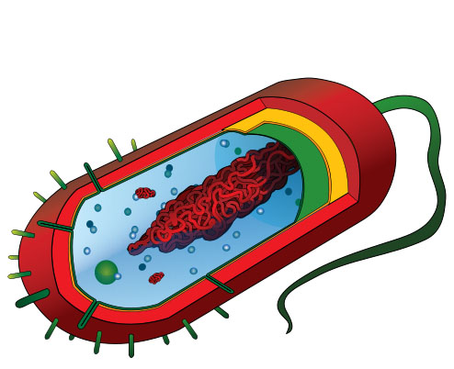
Image: Prokaryotic Cell by Mariana Ruiz
1
3
4
5
6
7
8

- ___________-_____________________________________________________________________

- ___________-_____________________________________________________________________

- Cell Wall - _______________________________________________________________________

- ___________-_____________________________________________________________________

- ___________-_____________________________________________________________________

- Plasmid - _________________________________________________________________________

- Ribosome - _______________________________________________________________________

- Fimbria - _________________________________________________________________________

