Microbial Metabolism & Specialized Bacterial Growth Media Homework Assignment

Name: ____________________________________

The purpose of this exercise is to help students improve their understanding of selective and differential bacterial growth media, and how the media allows for the identification bacteria based on metabolism.

Qs: What is the medium in top picture?

• Is selective …Why? What does it grow?

• Is differential …Why?

• What does the differential property reveal about the bacteria growing there?

Qs: What is the medium in bottom picture?
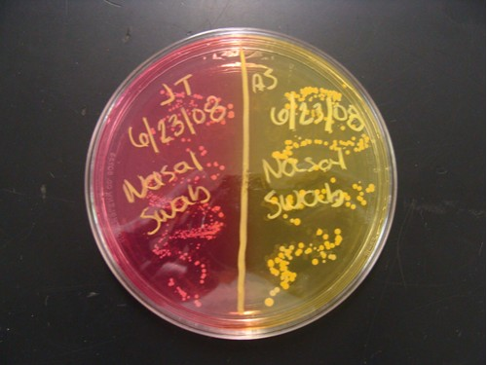

• Is selective …Why? What does it grow?

• Is differential …Why?

• What does the differential property reveal about the bacteria growing there?

