Laboratory Project 3
Differential and Selective Bacterial Growth Media

Session 1
Readings:
- This laboratory guide
- Bauman: p. 174-84
- Lab Readings linked on the Differential & Selective Bacterial Growth Media Laboratory Main Page of the Virtual Microbiology Classroom

Purpose:
The purpose of this laboratory is to provide opportunities for student (1) practice the techniques of pouring and inoculating media (2) interpret growth of bacterial culture on media and (3) apply the characteristics and uses of a small selection of media.

Outcomes:

After you complete this lab, you will be able to:
- Identify the controls in an experiment.
- Define negative and positive control.
- Apply the definitions of controls to determine the validity of an experiment.
- List two functions of controls.
- Employ controls in all experimental designs.
- Consistently inoculate media appropriately.
- Describe and employ the basics of aseptic media, culture and specimen transfer.
- Describe the impact of normal body flora and environmental sources of bacteria relative to aseptic technique.
- Understand the ubiquitous nature of bacteria.
- Identify sterile areas of the body.
- Perform aseptic technique, streak plate techniques, plate labeling and incubation.
- Describe how ingredients of media influence what you see on the plate.
- Describe the use of differential and selective media.
- Interpret growth on and/or use of the differential media and selective media used in the laboratory exercises.
- Describe how the characteristics of media might allow you to identify bacteria.
- List the ingredients in a particular medium that make it differential or selective.
- Explain how media ingredients select for or suppress groups of bacteria or differentiate among groups of bacteria.
- Collect and interpret data regarding the identity of an “‘unknown” bacterial culture.

Terms to Know:

Be able to define these terms and apply them in the laboratory.
Agar | Enterococcus | normal flora
alpha, beta and gamma hemolysis | group A ß-hemolytic strep | pH indicator
aseptic technique | hemolysin | positive control
autoclave | inoculate | selective media
blood agar | isolated colony | Staphylococcus aureus
Broth | MacConkey’s | Staphylococcus epidermidis
clinical sample | mannitol salt | streak plate
colony morphology | medium/media | sterilization
differential media | mesophile | Streptococcus pyogenes
Enterobacteriaceae | negative control | TSY

Introduction
Our bodies are composed of 100 trillion (10¹⁴) cells. We are inhabited by a quadrillion (10¹⁵) bacterial cells, known as normal flora. Normal flora is found on any exposed surface of the body (i.e., skin and mucus membranes), but healthy internal organs are sterile – no bacteria live there.
You are colonized at birth. Most of the bacteria that are there are long-term inhabitants. Others, called transient flora, are just passing through.
Our normal reaction to the notion that we are covered in bacteria is “YUCK!!” However, with all that bacteria do for us, this is a misguided reaction. Normal flora takes up space (preventing pathogens from moving in and setting up housekeeping), consumes the scant nutrients available (again, competing with potential pathogens) and puts out waste products that keep other less desirable microbes from setting up shop. In this lab you will investigate the normal-flora microorganisms that inhabit the different surfaces of your body.
Bacteria and other microbes have particular requirements for growth. In order to successfully grow bacteria in lab so that we can stain and identify them, we must provide an environment that is suitable for growth. Growth media (singular: medium) are used to cultivate bacteria. Media are mixtures of nutrients that the microbes need to live. They also provide the necessary moisture and pH to support microbial growth. Bacterial cultures are incubated at temperatures known to be best for their growth. The bacteria that live on your body surfaces are mesophiles – they grow at temperatures between 25° and 45°C.
The medium that we use most often is designated "TSY" (tryptic soy agar). It is a complex nutrient medium that supports the growth of a wide variety of microbes (NOTE: this means TSY is neither selective nor differential!). When the lab personnel make a medium, they measure out a designated quantity of dry powdered medium, add a designated amount of water and check the pH. They dispense the medium into bottles, cap it and autoclave it. Autoclaving is a process similar to home canning techniques of food preservation. Once the medium is autoclaved (or pressure cooked), it is considered sterile. The autoclave exposes the medium to high temperature (121°C) and pressure (15 psi) for 20 minutes. This exposure has been demonstrated to result in sterilization. (Sterilization is the process of killing all life forms.)
Many normal-flora microorganisms and clinically important microbes can be grown either in liquid medium (sometimes called broth) or on Petri dishes (also called Petri plates, or just plates). When microbes are grown on plates, agar is added to the liquid medium so that, when cool, the medium has the consistency of very stiff gelatin. Agar is an inert seaweed extract that solidifies at room temperature.
You will practice making streak plates in today’s lab. The streak-plate method is essentially a dilution technique that systematically spreads the bacterial cells over the surface of the medium to achieve growth of isolated colonies. Streaking a sample of bacteria on a plate as described in this lab results in dilution and separation of bacterial cells. When a plate is incubated after the sample has been streaked, each cell divides many, many times by binary fission and forms a colony. A colony that is not touching other colonies is said to be isolated, and all the cells in that colony are assumed to have arisen by division from a single cell. (FYI, a colony that is just barely visible to your eye contains at least a million cells!)
To identify the bacteria in a sample, you first make a streak plate — and then observe the plate after incubation. It is obvious from the appearance of the colonies (i.e., from the colony morphology) if the sample contained one or many kinds of bacteria (Bauman p. 15, Fig. 1.17). If only one colony morphology is present on the plate, then all the colonies will look the same (same color, shape, elevation, etc.). If a plate contains many colonies of only one colony morphology, then the plate is said to be a pure culture of bacteria. Colonies that appear different are, in fact, different genera and/or species of bacteria. If many colony morphologies are present, then the specimen contained a variety of microbes. If a sample contains multiple kinds of bacteria, making a streak plate is the first step in obtaining pure cultures of each so they can be identified.
Today you will also begin to learn about aseptic technique. Aseptic technique means that in handling bacteria, you don’t introduce environmental or other contaminating microbes into your experiment. It also means that you do not become contaminated with the microbes you are working with. Microbiologists use aseptic technique when they pour TSY medium into Petri plates and when they inoculate specimens onto the media, as well. You also will aseptically make a streak plate.
Finding and identifying the culprit causing a bacterial infection in a patient is sometimes like finding a needle in a haystack. Sometimes, microbiologists employ a culture medium that provides a comfy cozy growth environment for one type of microbe while making others miserable. This type of medium is known as a selective medium. There are many different types of selective media. Each contains substances (e.g., dyes or salts) that inhibit the growth of some bacteria while allowing others to thrive. In this way, if disease-causing bacteria are in a clinical sample, they can be “selected” to grow on this medium while the normal flora caught up in the dragnet of the specimen collection is selected against and does not grow on the selective medium.
Another tool in the microbiologist’s toolbox is the differential medium. A differential medium distinguishes groups of bacteria as they grow on the medium – you can see a difference. The different groups are often distinguished, or differentiated, on the basis of colony color on the differential medium or by some other characteristic that is rather obvious. Sometimes the characteristics of selective and differential media are combined in one medium. Such is the case for the MacConkey’s and the mannitol salt media used in this lab — both are differential and selective.
- MacConkey’s has a TSY-like composition to which a carbohydrate (lactose) and other ingredients (crystal violet, bile salts and a pH indicator) have been added. It is selective, because its crystal violet and bile salts inhibit the growth of some organisms (Gram-positive bacteria). It is also differential because of the addition of lactose and the pH indicator. Lactose fermenters (bacteria that metabolize lactose and produce acidic metabolites that cause the pH indicator neutral red to turn pink/red) will grow in pink/red colonies, while non-lactose fermenters will be colorless and clear. Members of the family Enterobacteriaceae (Gram-negative bacilli) are commonly isolated from urine cultures, because the Enterobacteriaceae are members of the normal flora in your intestinal tract. They are most commonly lactose fermenters. MacConkey’s is a tool in the medical technologist’s tool box; it enables her to suspect the culprit in a UTI after a preliminary observation (Bauman p. 181, Fig. 6.14).
- Mannitol salt is selective, because it has a high concentration of NaCl (7.5%). Most bacteria cannot survive in this high-salt environment, but species in the genus Staphylococcus grow well in this medium. Mannitol salt is also differential in that it contains a pH indicator that changes from red to yellow in the presence of acid. Staphylococcus aureus is able to ferment the sugar mannitol, producing acid as a product, which turns the pH indicator from red to yellow. This ability to ferment mannitol distinguishes Staphylococcus aureus from Staphylococcus epidermidis.
The two examples above may lead you to think that all special media are both differential and selective. This is not true. An example of a medium that is differential, but not selective is blood agar. Many specimens received in a clinical microbiology lab are plated onto blood agar, because it supports the growth of a wide range of medically important organisms. It is even richer than TSY, and more organisms will grow on blood agar than on TSY. Remember, TSY is not selective because it does not suppress the growth of any microbes, but rather supports the growth of a broad range of bacteria and fungi. By the same token, blood agar is not selective and because it is an enriched medium, it supports a more broad range of microbial growth. Blood agar is differential, and microbiologists can easily distinguish some clinically significant bacteria by their appearance, or hemolysis pattern, when cultured on blood agar (Bauman p. 180, Fig. 6.12). Blood agar contains 5% sheep’s blood. Certain bacteria produce extracellular enzymes called hemolysins that lyse the red cells completely (beta-hemolysis), producing a clear zone around the colony. Other bacteria produce hemolysins that produce a greenish discoloration around the colony – indicating incomplete hemolysis (alpha-hemolysis). Still other bacteria have no effect on the red cells (gamma-hemolysis). Blood agar is often inoculated from a patient’s throat swab. (This swab is an example of a clinical sample. A clinical sample is a sample of a tissue taken from a patient for diagnostic purposes.) The microbiologist is trying to detect the presence of group A beta-hemolytic streptococci (Gram-positive cocci that cause beta-hemolysis on blood agar). The major human pathogen in this group is Streptococcus pyogenes, the causative agent of strep throat. Normal throat flora will exhibit alpha- or gamma-hemolysis, but not beta-hemolysis.
Controls
For most of the experiments that you perform in this course, you will include controls. Controls are samples whose identity you already know that are subjected to the same procedures as your unknown sample. A positive control is a known sample submitted to the procedures that will show you a positive answer. In this exercise you inoculate sectors on the control medial plates with laboratory stock bacteria because you know (initially, by looking up the organism in your text, lab manual or on-line; later, you’ll know this from the experience of working with the organism and various media) how these bacteria are supposed to behave on a particular medium.
For instance, in this exercise you inoculated mannitol salt media with Staphylococcus aureus (S. aureus) and Staphylococcus epidermidis (S. epi). These are both positive controls for the selective nature of the mannitol salt agar because they will both grow on the media. Only S. aureus, however, is a positive control for the differential nature of mannitol salt because it will ferment the mannitol, drop the pH of the surrounding media and cause a color change to occur. The media will change from pink to yellow.
A negative control is a known sample that should show you a negative result. In the example (above) of the mannitol salt media S. epi is an example of a negative control for the differential nature of the media. S. epi does not ferment the mannitol and so no media color change occurs. E. coli might be considered a negative control on the selective nature of mannitol salt media.

Procedures
Project 3, Session 1

Each student will set up a throat culture on blood agar and a nasal swab on mannitol salt. After completing the inoculation of these two media, each student will receive a test tube containing a TSY media slant of unknown bacteria. You will inoculate the unknown bacteria on to the standard lab media. Additionally, your table will set up a set of controls for each media plate.
Inoculate throat and nasal cultures
1. A group of two lab partners should obtain one mannitol salt agar and one blood agar plate.
2. Use the Sharpie marker to draw a line on the bottom each plate to divide the plate in half. Label each half with the initials of the lab partners. (See Figure 3.1a and 3.1b)
3. Aseptically obtain a sterile cotton swab from the sterile test tube on your bench. GENTLY swab the back of your throat and inoculate the cotton swab on your half of the blood agar plate. Careful not to gouge the media.
4. Discard the contaminated cotton swab in the biohazard container.
5. Using a second sterile cotton swab gently obtain a culture from your anterior nares. Swab your half of the mannitol salt plate.
6. After your lab partner has inoculated her side of the media, label the plates with the date and store them media side up (upside down) in the green bin labeled for your section.
Inoculate your unknown using various media
1. Obtain a TSY, mannitol salt agar plate, MacConkey’s agar plate. Be careful not to open the plates until you have been directed.
2. Using a Sharpie^{tm}, label each plate on the bottom (medium side) with your initials and the date. NOTE: Always write on the part of the specimen that cannot be altered or misplaced. (See Figures 3-1a and 3-1b)
Figure 3-1b: Plate Labeling
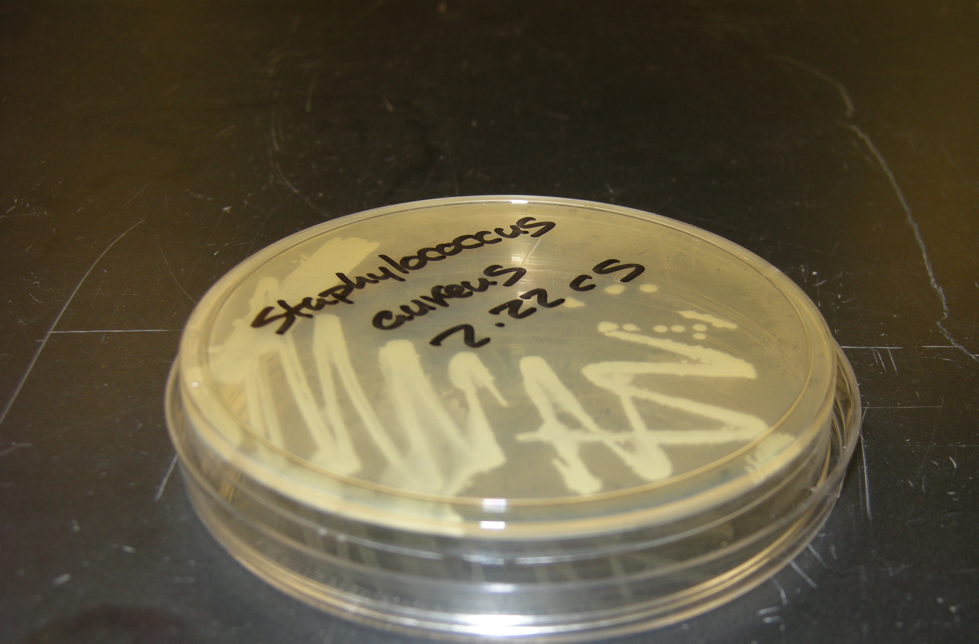
Write with wax pen on this side of the plate.
Top

Bottom

Figure 3-1a: Plate Labeling
Bottom

Top

3. Inoculate the TSY plate using the isolation streak plate method:
a. Pick up the inoculating loop and sterilize it in the Bacti-Cinerator® IV as demonstrated. (Procedure: Hold the loop in the ceramic hub of the Bacti-Cinerator® IV for 5 seconds. Remove and allow it to cool before use. Do not insert the loop into the Bacti-Cinerator® IV and allow it to sit unattended — it will turn to molten lava!)

b. After the loop has cooled, aseptically insert it into the test tube slant of your unknown bacteria.
(1) Remove the cap, pass the top of the tube through the flame of the Bunsen burner two times
(2) Using your sterilized, cooled loop, obtain a small sample of your unknown from the source tube by gently dragging the loop over the media surface in the slant tube for about ¼”.
(3) Gently touch the surface of the TSY media plate in the following manner:

i. Gently inoculate the first quadrant of the TSY media as illustrated in Figure 3.2.

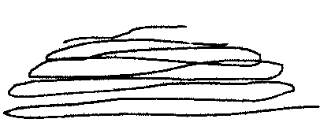
Figure 3.2: First Quadrant Streak

Quadrant #1

ii. Sterilize the inoculating loop as directed in 3a.
iii. Allow the inoculating loop to cool, remove the Petri plate lid and turn the plate 90°. Touch the loop to a corner of the culture in quadrant 1 and drag it several times across the agar in quadrant 2. Tease out of quadrant #1 only 2 or 3 times and then continue your streak, but do not dip back into quadrant #1 (Figure 3.3).
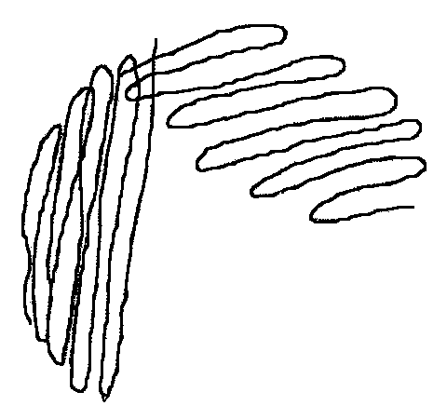
Figure 3.3: Second Quadrant Streak
Quadrant #1
Quadrant #2

iv. Sterilize the inoculating loop in the Bacti-Cinerator® IV.

v. Give the plate a 90° turn and begin the inoculation of quadrant #3 by placing your loop in quadrant #2. Again, tease out some of the bacteria into quadrant #3 in the manner indicated in Figure 3.4.

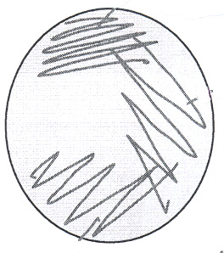
Figure 3.4: Third Quadrant Streak
Quadrant #2
Quadrant #3
Quadrant #1

vi. Sterilize the inoculating loop in the Bacti-Cinerator® IV.
vii. For your final quadrant streak, touch quadrant 3 only one time, and then streak quadrant 4 in the manner indicated in Figure 3.5

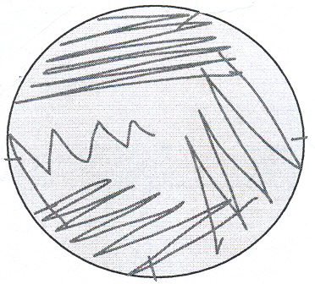
Figure 3.5: Fourth Quadrant Streak
Quadrant #1
Quadrant #2
Quadrant #3
Quadrant #4

k. You have just completed a “streak plate” of your unknown on TSY.
4. Repeat the streak plate technique as you inoculate your unknown bacteria on Mannitol Salt (MSA). When done with MSA, do a streak plate onto MacConkey’s (MAC)
5. Place your labeled plates upside down in the green “save” bin for incubation at 37° C for 24 hours. They will then be removed from the incubator and stored until your next lab.
Inoculate a set of controls for your lab bench
Each table will must set up one set of controls for the media. The members of a bench or assigned group must work together to set up one set of control media.
a. Obtain one each of TSY, mannitol salt & MacConkey’s. Use the Sharpie^{tm} marker to draw 5 sectors on the bottom of the plate. (See Figure 3.6) Label the sectors 1 through 5.
b. Select the media slant of Staphylococcus epidermidis. Streak the inoculums to sector #1 of the TSY plate. This streak is not intended to be an isolation streak. Transfer the inoculums by gently gliding the inoculating loop back and forth over the media within the confines of sector #1, in a tornado shaped pattern.
c. Sterilize your loop and repeat the transfer of control bacteria to TSY sectors as follows:
i. Place Staphylococcus aureus in sector #2.
ii. Place Escherichia coli in sector #3.
iii. Place Salmonella pullorum in sector #4.
iv. Sector #5 is the negative control. This means you should sterilize your loop, but do not pick up any bacteria. Use the sterile loop to inoculate sector #5. (Again, see Figure 3.6)
d. Repeat the process of transferring control bacteria to the MacConkey’s and then mannitol salt.
e. Label the media side of the plate (your group’s name, the identity of the media and bacteria and the date) and place the plate media side up (or upside down) in the green bin labeled as storage for your lab section.





1
2
3
4
5
Figure 3.6: Streak Patterns for Control Specimens

Laboratory Project 3

Differential and Selective Bacterial Growth Media

Session 2
Introduction
Last session, you inoculated your unknown bacteria and control bacteria on various types of laboratory media. This week you will look at those plates and read the results. To do this you will:
- Practice observing colonies for characteristics that distinguish different colony types.
- Make general observations about the number and type of microorganisms found on your arm, hands, throat and nose and the laboratory stock cultures on various media.
- Gain experience interpreting selective and differential media.
- Determine the genus and species identification of a bacterium given its growth patterns on various laboratory media.
You will recall that last week, you plated samples on TSY, and also on mannitol salt, MacConkey’s and blood agar. The two reasons these differential (in the case of blood agar) or differential and selective (in the case of mannitol salt and MacConkey’s) media were used were:
1. They provide insight into the type of organisms being isolated.
2. They show you how a medical technologist might find the “needle in a haystack.” That is to say, the choice of medium or media provides a way to quickly distinguish a potential pathogen from normal flora.
The technologist may use colony morphology on the differential or selective medium to determine whether or not the “suspect” should be further worked up for genus and species identification and antibiotic sensitivity. It is important to realize that you cannot conclusively identify bacteria based on colony morphology. You must perform tests (stains, growth tests, biochemical tests) designed to distinguish different bacteria. Colony morphology may provide a hint as to the identity of a bacterium and suggest what tests you might want to perform in order to establish the genus and species identification.
While we used stock cultures of laboratory bacteria for your unknowns, in clinical practice the unknown is a specimen from a patient. For instance, a throat swab would typically be inoculated on blood agar. The type of hemolysis the specimen exhibits on the blood agar provides valuable insight regarding the potential pathogens present. In a throat culture, the primary pathogen to watch for is Streptococcus pyogenes, which is a group A beta-hemolytic streptococcus. Most normal-flora microbes found in the throat exhibit alpha- hemolysis on blood agar; usually, this is caused by a group of streptococci called “viridans” streptococci because they cause alpha-, or green, hemolysis (virid is Latin for green). Sputum cultures are also routinely plated out on blood agar. In this instance, the pathogen to watch for is Streptococcus pneumoniae (alpha hemolytic strep). Note that the type of clinical sample that has been plated out may provide a piece of the puzzle: a throat swab was probably taken because the patient had a sore throat, possibly strep throat, whereas the sputum sample probably came from a patient with lung congestion and possibly pneumonia.
You streaked a nose swab out on a mannitol salt plate. Methicillin-resistant Staphylococcus aureus, or MRSA, continues to increase in prevalence, and some facilities are actively screening patients or residents for MRSA. The 7.5% NaCl composition of the mannitol-salt agar suppresses the growth of all non-Staphylococci, and the medium easily and quickly distinguishes Staphylococcus aureus from all other Staphylococci. Once growth is observed, as you will recall, the microbiologist looks for the typical yellow color that signifies Staphylococcus aureus has been growing there and fermenting the medium’s mannitol to produce an acidic waste product that decreases the pH of the medium, which is what causes the pH indicator to change color from pink to yellow. (It is easy to remember that Staphylococcus aureus turns a mannitol salt plate yellow if you remember that aureus refers to gold.) If the plate has retained its pink color despite the obvious growth of bacteria, then your garden variety Staphylococcus (most likely S. epidermidis) is present. If an individual were colonized with Staphylococcus aureus, the technologist could then perform antibiotic sensitivity testing to determine if the S. aureus were MRSA.
MacConkey’s medium is selective in that its bile salts and crystal violet suppress the growth of Gram-positive bacteria while the medium supports the growth of Gram-negative bacteria. One common use of MacConkey’s medium is in situations where infection or contamination with fecal bacteria is suspected, because Gram-negative organisms predominate in the colon. In hospital settings, urinary tract infections (UTIs) are common (40% of nosocomial infections are UTIs), and the majority are in patients with urinary catheters. Most of these infections are with Escherichia coli, Pseudomonas aeruginosa, Klebsiella and Enterobacter species, all of which are Gram-negative. E. coli, Klebsiella and Enterobacter are Gram-negative bacilli called coliforms. All are members of the family Enterobacteriaceae and are normal gut flora. They all grow on MacConkey’s plates, as does Pseudomonas, another Gram-negative bacillus that is more commonly an environmental bacterium.
In addition to telling the technologist that a UTI has been caused by a Gram-negative organism, MacConkey’s can also tell the technologist if the organism is likely to be a coliform. Coliforms can ferment the sugar lactose, whereas Pseudomonas cannot. MacConkey’s medium includes the sugar lactose along with a pH indicator. If a bacterium growing on MacConkey’s can ferment the lactose, it will secrete acid as a metabolic end product, and this acid will change the color of the pH indicator in the medium. Lactose fermenters appear as pink colonies, whereas non-coliforms do not appear pink on MacConkey's. Using a MacConkey’s plate in addition to a TSY will therefore tell the technologist if the UTI is caused by a Gram-negative organism, and if so, whether the organism is a lactose-fermenter. These results narrow down the possible infecting organisms and tell the technologist which test to do next to get a genus and species identification of the bacterium.
Last week you were provided with a bacterial culture of unknown identity. The bacteria was inoculated onto the laboratory media. This bacterial unknown is meant to be a simulation of the clinical environment where the medical microbiologist is routinely asked to identify the genus and species of a bacterial unknown from a patient specimen. This week you will record your observations of growth or no growth of your unknown on a particular medium and you might indicate color changes in the colony or in the media. The ability of a microbe to grow on the media provides insight to its genome. Some bacteria have a gene that provides for a physiological characteristic (e.g. cell wall structure, formation of a glycocalyx) or a metabolic feature (e.g. ability to utilize mannitol or lactose) that allows them to utilize the media in a predictable way. When this happens (i.e. fermentation of mannitol) the microbiologist infers that the bacteria utilizing the mannitol have a gene that codes for mannitol dehydrogenase; the gene directs the cell to make this enzyme protein and the enzyme breaks down the mannitol. From our previous discussion, you know the bacterium Staphylococcus aureus carries this gene, but its genetic cousin, Staphylococcus epidermidis does not. Bacteria with like genomes are closely related; that is to say they belong to the same genus and species.

Procedures
Project 1, Session 2
Prior to lab your will need to devise a table for recording your results. Remember that you have been directed to provide the data on which your interpretations are built in an on-going effort to pursue critical thinking and root out error. Think about the type of data you need to collect. Perhaps you will have two or three tables of data (e.g. clinical specimens, unknown, controls. For instance you might consider a data table for the nasal and throat cultures (i.e. clinical specimens) like the following:
Table 1: Results of cultures on clinical specimens
Specimen | Media | Description of the Results | Interpretation

The digital camera will be available for use in the lab. You may take photos to document your results (and develop a study tool for the lab practical!)
Once you have recorded your results you will interpret your findings. For instance, when interpreting the throat culture you should be able to determine the presence of normal flora and characterize it. If a suspected pathogen is present, you should be able to identify the characteristics that make you suspicious. The growth patterns of the unknown bacterium should be interpreted using the dichotomous key of expected results for groups of bacteria. A dichotomous key for this purpose is posted on Moodle.
Boot up your laptop computer and sign on. Report the results you have obtained during the second week of this lab project, after the plates were incubated at 37° centigrade for 24 hours and stored. Save the results to the student “O” drive. Before you close the document, open your KVCC e-mail account. Email the document as an attachment to BOTH you and your lab partner.

LAB REPORT
You have been given prototypes for the last two lab reports. Use the same format to complete the write up of Project #3. In your introduction you might include discussions of your understanding of the use of media, differential and selective media and aseptic technique. When you performed the differential stains you learned about positive controls; in this lab you learned about negative controls. Consider a discussion of this topic in your introduction as well. When you report your results remember that you will turn in one lab report for two lab partners so record the results of unknown cultures for each student. A significant portion of your grade will be based on interpreting your results so make certain a proposed identification of the unknown is accompanied by the unknown number and clearly labeled.

