Laboratory Project 5
Testing Amount of Bacteria on Different Types of Food Items
Readings:
- Bauman: Chapters 9 and 10 and p. 577, 615, 773
- Lab manual page 80-81 (sections on Colony Counts and Dilutions)
- www.ableweb.org/volumes/vol-27/10_Hoefnagles.pdf
- http://aggie-horticulture.tamu.edu/extension/poison.html
- http://www.consumersunion.org/pub/core_food_safety/002278.html

Purpose:
The purpose of this experiment is to become familiar with the quantity of bacterial contaminations of raw food and the basic lab techniques for such determinations. Students will also become acquainted with a technique for testing an agent of control and evaluating its effectiveness.
Outcomes:
After you complete this lab, you will be able to:
- Perform microbial sampling of an environment
- Employ standard precautions to avoid contamination
- Use a given technique to obtain a microbial sample from a contaminated source
- Perform and interpret serial dilutions
- Properly use micropipets
- Aseptically perform a serial dilution
- Perform colony counts
- Determine Colony Forming Units present in the original sample

Session 1
Introduction
WASHINGTON, May 2, 2001--Thorn Apple Valley, Inc., a Forrest City, Ark., meat and poultry plant, was sentenced April 10 in federal court for violating the Poultry Products Inspection Act, the U.S. Department of Agriculture’s Food Safety and Inspection Service announced today.
Thorn Apple Valley, Inc. was sentenced on one felony count of distributing chicken and turkey frankfurters that were adulterated with Listeria monocytogenes, a foodborne pathogen. The U.S. District Court for the Eastern District of Arkansas ordered the plant to pay a $50,000 fine and a special assessment fee of $400.
This action is the result of an investigation by FSIS compliance officials. FSIS is responsible for ensuring that meat, poultry, and egg products are safe, wholesome, and properly labeled.
Source: http://www.fsis.usda.gov/OA/news/2001/thorn.htm
The above article represents an actual news item about a poultry processing plant that was fined for distributing poultry products that were contaminated with harmful bacteria. You have no doubt heard of other instances in which severe illness, or even death, resulted when consumers ate contaminated meat, poultry, or other foods.
You have been hired by the Ain’t-No-Thang-but-a-Chicken-Wang (ANTCW) Poultry Company of Arkansas to measure the number of microbes contaminating their raw chicken wings and produce. The ANTCW Poultry Company wants you to experimentally test the amount and type of microbes present on their chicken wings. The executives of this fictional company are concerned about the safety of their food products, and they do not want to be liable for the spread of foodborne bacteria such as Salmonella.
During the first week, team members will learn how to measure the microbial contamination of raw chicken wings. To do this you will apply bacteria that you wash from store-bought wings to a tryptic soy agar (TSY). You will also gather information on the type of bacterial present on the food by using MacConkey’s and Mannitol salt plates.
During the second week, you will collect and analyze your bacterial counts. Each student must use the data collected during the second week to write a short report to the ANTCW describing your findings. You will be asked to analyze both individual and class results.
Warning: Take good notes on the exact procedures your group uses throughout this lab! You will NOT remember the details if you don’t write them down! Include every detail, including all instances where you think you MIGHT have messed up (don’t worry, you wouldn’t be the first to make a mistake, so don’t be afraid to document it). You’ll need these details to write up your experimental design, interpret your data, and write your report. Remember, no detail is too small to write in your notes, because you never know what you’ll need later. Also, be very precise in labeling your plates!
The best way to approach this lab is:
- For all team members to meet over a printout of the Procedure: Session 1 section of this exercise.
- Discuss very specifically what each team member is going to do, even diagram it out, on paper, to make sure everyone understands.
- Label all test tubes and plate before beginning the lab project.
- Carefully read the instructions as your proceed.
Background
The following pages contain important information about the rationale behind two important microbiological techniques (plate counts and serial dilutions), how to work safely and effectively with microorganisms, and food preservation.
In this lab, we will wash store-bought chicken wings with sterile saline solution, then count the bacteria in the wash fluid. Unfortunately, it is very likely that the wash fluid will have so many bacteria that no matter how tiny the volume we plate, we will end up with way too many colonies on the plate. They will all crowd together and it will be impossible to get an accurate count. The solution to this problem is called the serial dilution: a series of 10-fold dilutions of the original wash fluid. The objective is to find an optimal dilution that results in a density of bacteria that can be accurately counted (plates between 30 and 300 colonies are considered to be “countable”). Since we don’t know how many colonies are present until next week, we need to plate many different dilutions and see which produce(s) countable plates. Details of these procedures appear in a subsequent section of this lab.
Note on Safety
You will handle raw chicken, possible contaminated with human pathogens, in this lab. You will also work with open flames. For your safety, and for the safety of your friends and roommates, please:
- Wear gloves whenever you handle raw chicken.
- Dispose of the chicken, and anything that touches raw chicken, as directed by your instructor.
- Whether or not you touched chicken, wash your hands thoroughly before you leave the lab.
- Because each group will use open flames and highly flammable alcohol, employ all the safety precautions you have learned throughout the term and please, please, please do not horse around.

PROCEDURES
Session 1
Work in groups of up to four for this lab exercise. Additionally, your group of four may work together to perform the Control Lab (Project 6) where you may draw on the experience of group members as you design and interpret the control experiment.

Divide your team of four into two – 2 person groups. Each group of 4 will be given one chicken wing. Duplicate, or replicate, tests will be performed by each 2 person group on the same food item. Identify each 2 person team as team “A” or team “B” so you can organize your replicate plates during week two of this exercise.

Figure 5-1. How to label your test tubes and petri dishes.

Replicate
A or B
Dilution


Group Member’s Initials
Dilution:
Replicate A or B

Test Tube Labeling
For each food item your team should label tubes of sterile saline for your dilutions (i.e., 10⁻¹ through 10⁻⁷) PLUS an empty tube for your original wash solution. Label your one additional tube of sterile saline “NEGATIVE CONTROL”. Total tubes labeled = 18 per group of 4 students

Petri plate Labeling
Each team will set up plates from the food item (chicken wing or produce) wash. Team A (replicate #1) and Team B (replicate #2) for each of the five dilutions (10⁻³ through 10⁻⁷). Note, you are not plating all dilutions. LABEL the remaining plate with your initials and “NEGATIVE CONTROL”. Each team will need a heat sink. Total TSY plates labeled = 14

1. Aseptically pour 14 TSY media plates for each team of 4 students. Remember to maintain aseptic conditions, keep the test tubes and petri dishes closed as you label them.
2. Obtain four Mannitol Salt and four MacConkey’s plates.
Label the plates as they are inoculated as indicated in Figure 5-2. Double check your labels.

Figure 5-2: Labels of Mannitol Salt and MacConkey’s plates
CS Mannitol Salt
10^{-?}
Wing #1
Label each plate with the group member’s initials, plate name, dilution factor and chicken wing replicate (#1 or #2). Instructor will indicate which dilutions you are plating onto MAC & MSA.

3. Obtain 2 empty sterile test tubes and 16 tubes containing 9 mL of sterile saline
a. Each group of 2 students should arrange a set of tubes (one empty and 8 tubes containing saline) in a test tube rack. See Figure 5-3.
b. Each group should label the tubes in the rack as indicated in Figure 5-4.
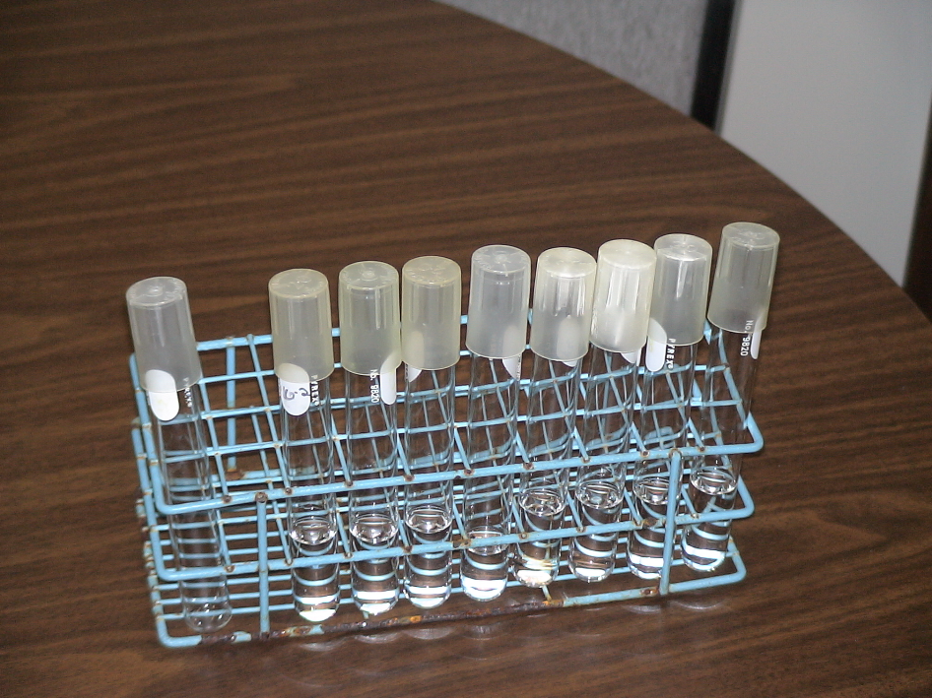
Figure 5.3: Arrangement of Test Tubes in the Test Tube Rack
empty test tube
8 test tubes
Sterile saline

4. Obtain one chicken wing for your group of 4. Aseptically place the wing in a separate resealable plastic sandwich baggie.
a. Aseptically add 20 mL of sterile saline solution (0.85% NaCl) to each bag.
b. Seal each bag while pressing out most of the air.
c. Carefully wash the wing in the saline solution by gently massaging the bags for 5 minutes.
d. Use a sterile micropipette to aseptically transfer about 5 mL of the liquid in the bag to a labeled empty sterile test tube. Repeat this step for the second empty test tube. Now each team of two students is ready to set up a serial dilution of the chicken wing wash.
5. You are ready to prepare your set of serial dilutions of the wash fluid from the wash. (See Figure 5-4)
a. With a sterile pipette tip on the end of a micropipettor, aseptically transfer 1.0 mL (For 1.0 mL, set micropipette to 1000.) from the test tube containing the original wash fluid to the test tube labeled “10⁻¹”. Dispose of the used pipette tip immediately in the biohazard bag. The wash fluid has now been diluted 10 times, to 10⁻¹. Mix this tube using the vortex mixer. Be sure to put your finger over the test tube cap to hold it on.

b. Transfer 1 mL of the 10⁻¹ dilution to the tube labeled “10⁻².” Replace the test tube cap with a sterile plug and mix this tube using the vortex mixer.

c. Continue in this way through the 10⁻³, 10⁻⁴, 10⁻⁵, 10⁻⁶, and 10⁻⁷ dilutions by successively adding 1.0 mL portions to tubes containing 9.0 mL of sterile saline solution. Mix each tube immediately after adding 1 mL dilution to it.

Figure 5-4: Serial Dilutions
1:10 dilution
1:100
dilution
1:1000
dilution
1:10,000
dilution
1:100,000
dilution
1:1,000,000
dilution
1:10,000,000
dilution
Transfer
1 mL of original wash fluid to 10⁻¹
Mix 10⁻¹ & Transfer
1 mL of dilution to 10⁻²
Continue mixing and transferring dilution to each tube through 10⁻⁷
~~~~~
Original undiluted wash fluid
2-3 mL
~~~~~
Wing #
10⁻¹
9 mL Saline
~~~~~
Wing #
10⁻²
9 mL Saline
~~~~~
Wing #
10⁻³
9 mL Saline
~~~~~
Wing #
10⁻⁴
9 mL Saline
~~~~~
Wing #
10⁻⁵
9 mL Saline
~~~~~
Wing #
10⁻⁶
9 mL Saline
~~~~~
Wing #
10⁻⁷
9 mL Saline

6. Now you will inoculate the media plates. (See Figure 5-5)
a. Beginning with your most dilute tube, use a fresh, sterile 1 mL pipette to add 0.1 mL to a TSY plate. Plate out tubes 10⁻⁷ through 10⁻³ in this way.
b. Inoculate two Mannitol Salt plates, one from the 10⁻³ dilution tube and one from the 10⁻⁶ dilution tube.
c. Inoculate two MacConkey’s agar plates, one from the 10⁻³ dilution tube and one from the 10⁻⁶ dilution tube.
d. Transfer 0.1 mL of sterile saline from the negative control tube to the appropriately labeled TSY plate. For 0.1 mL of solution, set micropipette to 100. Save your heat sink TSY for incubation as well, this can serve as another negative control.

Figure 5-5: Inoculate Media Plates

When you take 0.1 ml from a tube and place it on a plate, you add one more dilution factor when you label the plate.
Example:
TSY 10⁻⁴ plate –Group A
Transfer 0.1 mL of 10⁻³ dilution to each >

10⁻³
Dilution

MAC 10⁻⁴ plate
Group A

MSA 10⁻⁴ plate
Group A

**Check your pipette carefully! You’ll need a micropipettor and sterile pipette tips. Make sure you are using 1/10 of a 1 mL or 100 uL. You may use the same pipette tip as you work from most dilute sample to most concentrated specimen. Also, mix each tube before you withdraw your sample!**

7. Immediately after adding the 0.1 mL of solution to the agar, use a hockey stick (a bent glass or metal rod) to gently spread the solution over the surface of the agar. Here’s how:
a. Sterilize the hockey stick: Take the hockey stick out of the alcohol bath and swipe the flattened end briefly through an open flame, just long enough to catch the alcohol on fire. Allow the flame to go out by itself. Don’t blow on it, otherwise you’ll introduce new microbes and/or fail to kill those that are already there. ***Don’t hold the burning hockey stick over the alcohol bath, or flaming drops of alcohol will ignite the bath. If this happens, do not panic. Simply place a lid over the alcohol bath, and the flame will extinguish itself.***
b. Spread your sample on the agar: Immediately after the alcohol has burned off the hockey stick, lift the lid of the Petri dish slightly. Briefly cool your hockey stick by lightly pressing the flattened end to a sterile area of the agar. Next, spread your sample droplet on the agar by using one hand to lightly drag the hockey stick back and forth over the droplet, while the other hand rotates the plate (your instructor will demonstrate). Press hard enough to ensure even distribution of microbes across the plate, but not so hard that you tear the agar surface.
c. Remove the hockey stick from the plate and replace the lid. Return the hockey stick to the alcohol bath.
8. Repeat steps 6 and 7 for each tube in your serial dilution. Remember, work from MOST dilute to LEAST dilute.
9. After you are done, invert your plates (lid-side down) and place in the green bin labeled for your lab section. Your instructor will incubate them at room temperature for 2-3 days to give colonies time to form, then refrigerate them until the next lab session.

Session 2
1. Procedures for Group A
a. Collect the plates that you inoculated during the first session of this lab project. Arrange the plates in order of dilutions. Place replicates of the same dilution near each other.
b. Count colonies for the plates that are countable (30 – 300 colonies). If there are a lot of colonies, you may want to draw quadrants on the bottom of the plate, count the colonies in one, and then multiply your count by 4. When you enter your counts in the Excel spreadsheet provided in lab, it will calculate CFUs per milliliter of wash fluid.
(1) Use a marking pen and a helper (and a dissecting microscope on low power if necessary) to mark and count the bacterial colonies on all plates with 300 or fewer colonies. Plates with more than 300 colonies do not produce reliable data and are therefore recorded as “TNTC” (too numerous to count).
(2) Record your data using the tables below.
(3) Use your raw data to decide which dilution produced valid counts. Remember, only plates with between 30 and 300 colonies are valid. For each wing, choose the dilution that best fits this criterion of validity. Record the valid counts from the appropriate plate for replicate A & B.
(4) Calculate the average number of colonies on the two replicate plates for the dilution that best met the criterion of validity (30-300 colonies):
Replicate A:

average count
Replicate B:

(5) Use the following formula to calculate the original cell density (colony-forming units, or CFU) per milliliter of wash fluid:
(6) Here’s a sample calculation:
number of colonies on replicate plates: 46 and 54; average = 50
mL plated = 0.1
dilution factor for plate = 10⁻⁶

(7) Now you do a practice problem:
If you plated 0.1 mL per dilution, and your counts for two replicate plates are 116 and 152, and the dilution factor for those plates was 10-4, how many CFU per mL of original wash fluid? (Answer is in the box below).
c. Compare the growth on the MacConkey’s and Mannitol Salt plates to the TSY plates. Use the technique for determining the CFU’s present on these plates.
d. Transfer your data to the Excel document on the laboratory computer. This document will be uploaded to Moodle when the class data has been collected.

Answer to practice problem:
Plate average = (116 + 152)/2 = 134 CFU
134/[(0.1) x (10⁻⁴)] = 13,400,000 = 1.3 x 10⁷ CFU/mL

Table 5-1: Plate Count Data Sheets

TSY |  |  |  | MacConkey’s | Mannitol Salt
Dilution | mL  plated | Colony Count |  | Colony Count | Colony Count
Dilution | mL  plated | Replicate A | Replicate B | A | B
10⁻³
10⁻⁴
10⁻⁵
10⁻⁶
10⁻⁷
Neg
Control

LAB REPORT:
You will complete one lab report for the group of 4 students using the standard lab report format. In your introduction you might discuss the reasons for making dilutions and when and why you are using them. Make the connection with the previous lab exercise (Project #4). When you analyze the data compare the data your group recorded to the class data. Discuss the validity of each and why one group (only your lab groups data versus the data from the entire class) might be preferred over the other. As you brainstorm ideas for future use, read over the procedure for lab project #6 and think about how you might use the techniques you learned in this lab to design and interpret the experiment you propose for Project #6.

