Laboratory Project 4
Urine Cultures and Identification of Unknown Bacteria
Readings:
- This laboratory guide
- Bauman, R. (2010) Microbiology 3rd ed, p. 176-8, 187-8, 572, D-11, 245-249, 297-8
- Bauman: pp. 107-9 (staining), 65-7 (cell walls)
- Bauman: Chapter 19 (Pathogenic Gram-Positive Cocci and Bacilli)
- Bauman: Chapter 20 (Pathogenic Gram-Negative Cocci and Bacilli)
- Lab Readings linked on the Urine Cultures & Bacterial Identification Lab Main Page of the Virtual Microbiology Classroom
- Guide to Laboratory Bacteria (Moodle)

Purpose:
The purpose of this experiment is for students to understand microbe identification in the context of a clinical situation. This lab uses the clinical simulation of the urine culture to more precisely define the process of determining the genus and species identification of a potential pathogen from a clinical specimen.

Outcomes:
After you complete this lab, you will be able to:
- Isolate and identify bacteria in an unknown sample.
- Perform an isolation streak plate.
- Make decisions about the type of tests that must be performed the test to confirm the genus and species of an unknown bacterium using the methods of colony morphology (using TSY), differential staining (Gram, Acid-fast, Endospore), differential and selective media (blood agar, mannitol salt, MacConkeys), and more specific laboratory tests (API 20E, bacitracin sensitivity test).
- Perform the tests, collect and interpret the data
- Relate urinary tract anatomy and potential urinary tract pathogens.
- Identify sterile sites in the healthy urinary tract.
- Identify sites potentially contaminated with normal flora.
- Distinguish between a contaminant and a urinary pathogen.
- Evaluate the impact of specimen collection on microbial assay and interpretation.
  - Compare the microbial identification of clinically significant microbes to the representative groups used in this student lab.
- Perform and interpret antibiotic sensitivity testing.
  - Identify the time necessary for performing the test.
  - Identify limitations of sensitivity testing.
  - Relate microbial structure to mode of anti-microbial action.

Terms to Know:

Be able to define these terms and apply them in the laboratory.
10-1, 10-2, 10-3, 10-4, etc. | distal | viable cell counts
<100,000 colonies/mL | differential media | proximal
>100,000 colonies/mL | enteric bacteria | quantitate
antibiotic sensitivity | Enterobacteriaceae | selective media
API 20E | Enterococcus | serial dilution
Bacitracin sensitivity | MacConkey’s medium | sterile specimen
calibrated loop | medical technologist | Taq
clean catch | mode of action | threshold
coliform | Nitrogenous base | urethra
colony forming unit

Urine Cultures and Identification
Session 1

Introduction
To gain familiarity with urine culture, you will be given a “patient’s urine” (one of the lab strains in broth culture) to investigate. After you have plated your unknown as if it were a clinical urine sample and evaluated those results, you will identify your unknown just as you did in the previous lab. In addition to the techniques of differential staining and the use of differential and selective media, you will add two more tests to your repertoire: API 20E and bacitracin sensitivity. The API 20E is designed to supply 20 different metabolic tests to distinguish the genus and species of Gram negative bacilli. The bacitracin test allows us to distinguish between the genera of Staphylococcus and Micrococcus.

Using Colony Counts to Estimate Number of
Colony counts provide a way to determine the number of viable microbial cells in a given specimen. One colony on a Petri plate represents one viable cell (one colony-forming unit) from the sample. The viable cell, once inoculated on the medium, divides by binary fission to form two cells. Each of the resulting cells continue to divide by binary fission (2 to 4; 4 to 8; 8 to 16; and so on) until a colony can be observed (at least a million cells must be present in order to be seen as a colony with the naked eye!). We report our results in terms of the number of bacterial cells per mL of urine.
To calculate this, we culture a small amount of the urine and then use unit analysis. For example, if we spread 0.1 mL of urine onto the plate and 100 colonies grow, this means there were 100 viable cells in 0.1 mL of the urine, which is the same as 1,000 viable cells in 1 mL of urine. Here’s the math:
Dilutions
In many samples, millions or billions of bacteria are present. When plated, even a small sample would give rise to so many colonies that they would run together and be hard to count. What is usually done is to plate a series of dilutions of the sample. You can always take the dilution factor into account when calculating the number of cells in the original sample. By doing a series of dilutions, you insure that one of the dilutions will give you colony numbers that are not too high or too low, but just right. You may use this serial dilution technique in later labs. A variant of this technique is to plate only a very small known amount of the sample on a plate.
The results are reported in cells/mL. For example, if 0.001 mL (1 microliter, abbreviated as 1 μl) is plated, the colony number must be multiplied by 1000, since 0.001 mL is 1/1000th of a mL. This serial dilution technique is used when the investigator has no idea how many bacterial cells are present. Plating serial dilutions increases the chance of (1) quantitating the bacteria and (2) isolating colonies of the different types of bacteria present.
In the clinical laboratory, this principle is applied to the microbial assay of urine. A urine sample is streaked on medium using a special inoculating loop known as a “calibrated loop.” The calibrated loop is calibrated so that it picks up only 0.001 mL of urine from the patient’s specimen. Thus, while no actual dilution is done, only a small volume (one microliter) is streaked onto a plate. When reading the results of the urine culture, the medical technologist takes into account that only 0.001 mL was plated, multiplies the results by 1000 and reports “colonies/mL.”
Although we would expect fluid stored in the bladder to be sterile, it must pass through the urethra as it exits the body. The distal portion of the urethra is colonized by normal flora. As the urine passes through this region, some of the normal flora gets caught up in the flow. Therefore, we would expect to find some bacteria in urine. The medical microbiologist must determine if the bacteria in a urine sample indicate a urinary tract infection (UTI). Complicating matters is that most of the bacteria that cause UTIs are part of the normal flora of the intestinal tract, likely the same ones that normally inhabit the distal portion of the urethra.
In the clinical lab, 0.001-mL urine samples are streaked on two media, TSY and MacConkey’s, and incubated at 37° C for 24 hours. At the end of the incubation period, the medical technologist counts the number of colonies on the TSY plate. (Each colony represents 1000 cells present in the original specimen. Why?) If the technologist counts 30 colonies on the plate, there were 30 cells in the 0.001 mL plated. This 0.001 mL is one-thousandth of a mL, so to calculate the number of cells per mL of the original urine sample, the technologist multiplies 30 colonies in 1/1000th mL x 1000 = 30,000 cells per mL of the original urine sample. The threshold (the minimum number of cells that must be present in order to suspect a UTI) is 100,000 cells/mL. Thus, a urine TSY plate with more than 100 colonies on it represents an original urine sample with more than 100,000 bacterial cells per ml. This far exceeds the number that can be picked up from the distal urethra. The bacteria are assumed to have come from the bladder and represent the organism causing the UTI.
Having > 100,000 cells/mL is the first criterion for a urinary tract infection. The second is that the colonies must be all one type. If these 2 criteria are met, the culture is slated for further “work-up.” A work-up involves the isolation of the potential pathogen, biochemical identification of the microbe’s genus and species and an antibiotic sensitivity test.
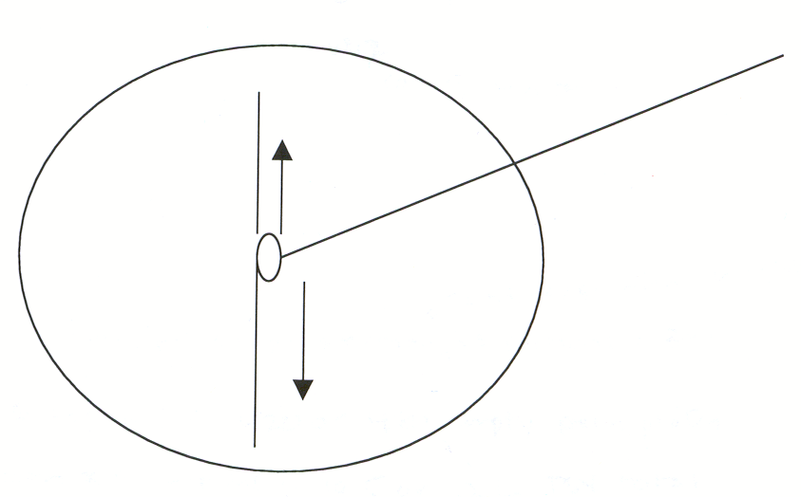
Procedures
Figure 4-1: Initial Inoculation of Urine on Media
1. Obtain a urine ‘unknown’ from your instructor.
Record the unknown identification number
2. Obtain one TSY, MacConkey’s (MAC).
3. Use the sterile, green plastic inoculating loop (which is calibrated to transfer 0.001 mL i.e. 1 microliter) to transfer 0.001 mL of urine from your unknown specimen to a TSY plate. Touch the loop initially in the center of the plate, and then spread the inoculum in a line across the diameter of the plate (Figures 4-1 and 4-2).
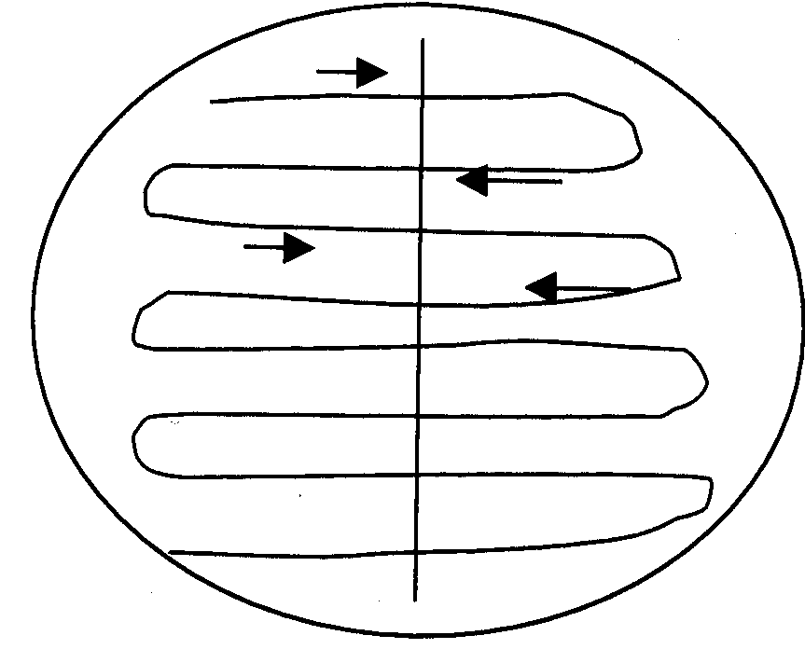
4. Then, without flaming the loop, inoculate the rest of the medium as demonstrated.
Figure 4-2: Distribution of Initial Streak of
Urine on Media Plates
5. Repeat steps 3 and 4, using the same calibrated
loop and your urine unknown, to inoculate a MAC.
6. Label your two inoculated plates with your initials,
unknown number or patient name, and the date, and
place them in the incubation bin. They will be incubated
at 37°C for 24 hours. You will read the results the next session.
8. In Session 2 you will identify the bacteria growing.

Urine Cultures and Identification
Session 2
Introduction
Last session, you plated out your unknown urine sample on TSY and and MacConkey's. Today you will determine if your sample indicates the presence of a urinary tract infection, and if so, you will proceed to identify the agent.
Two criteria must be satisfied in order to confirm the presence of a bacterial cause of a UTI. There must be:
- more than 100,000 colonies per mL of urine on the TSY plate
- only one colony morphology present

In clinical labs, whenever the criteria for a urinary tract infection (UTI) are met, a work-up follows: The genus and species of the bacterium are determined, and an antibiotic sensitivity assay is performed. After you have evaluated your sample as if it were a clinical urine sample, you will proceed to identify the bacterium. Proceed with identification as in the previous lab. If this is the case, consider your dichotomous key and determine the appropriate course of action. Set up the appropriate tests, and where necessary, save the plates and assays in the green “save” bin. They will be incubated and stored until the next session, when you read the results.
In addition to identifying your bacterium by the methods above, you will set up a test of antibiotic sensitivity for any pathogen you isolate. You will use a technique similar to the Kirby-Bauer method used in clinical laboratories. In this technique, a bacterial suspension is spread on the surface of a TSY plate so that when the bacteria grow, they will form a “lawn” of bacteria. Before incubation, you will place small paper discs impregnated with antibiotics on this plate. If an antibiotic inhibits the growth of the bacteria, then you will observe clear zones showing no growth around the antibiotic disc after incubation (zone of inhibition).
Procedures:
You will complete the antibiotic sensitivity for your unknown organism regardless of the method of identification you use.
1. Recall that the first step in identification of an unknown is the Gram stain. Complete this test, record your data, and interpret the results. You will need to include this data in your lab report.
2. Using your Gram stain as a guide, determine the identification tests you need to set up for traditional identification of a bacterium. The dichotomous key and previous laboratory experience provides the basis for this decision making. Acquire the necessary media/reagents, set up the tests, place the tests in the appropriately labeled green incubation bin for incubation and storage until next week.
- If you have determined that you have Gram positive bacilli then you must complete the acid fast and Endospore test. Use positive test results as your definitive test (e.g “I see endospores therefore, given the 8 laboratory stock bacteria, I know I have identified Bacillus subtilis”) rather than a negative test (e.g. “I do not see endospores on the endospore stain and the only other possible Gram positive bacilli is Mycobacterium smegmatis”).
- If you have determined you have Gram positive cocci, then you must set up the mannitol salt media and bacitracin sensitivity test. The instructions for this test are found in the next section.
- If you have determined you have Gram negative bacilli then you will set up the API 20E. The procedure for this test follows.
- If you have determined you have Gram negative cocci please determine your course of action and discuss it with your instructor before you continue.
NOTE: If you set up a test that is not needed you will be charged (i.e. penalty points will be deducted from your lab report) for the excess use of materials; if the lab work is not completed in a timely manner because you did not set up the appropriate tests in the correct order you will be charged with an ethics violation (i.e. penalty points assessed to lab report) because you caused a patient to suffer due to your improper decision making. You have a classroom full of colleagues. Use this fertile ground for discussion of what you plan to do and why you think it should be done this way.
3. Measure the Zones of Inhibition for your Antibiotic Sensitivity Testing. (See this Session 3 below).

The Bacitracin Test
Bacitracin is an antibiotic. The Bacitracin Test is a based on the disc diffusion Kirby-Bauer technique utilized for antibiotic sensitivity testing. The test helps identify Micrococcus luteus because Micrococcus is sensitive to Bacitracin; the zone of inhibition is greater than 30 millimeters. Other bacteria in the laboratory stock cultures have zones of inhibition less than 30 millimeters.
- Obtain a 3 TSY plates and 3 tubes each containing 10 milliliters of sterile saline.
- Select 4-5 isolated colonies from a pure culture plate of Staphylococcus epidermidis.
  - Use a sterile cotton swab to transfer the colonies to one of the tubes of sterile saline.
  - Label the tube with the name of the bacteria.
  - Discard the cotton swab in the biohazard bag.
- Repeat the process with Micrococcus luteus and your unknown culture.
- Dip a second sterile cotton swab into the Staphylococcus epidermidis bacterial suspension.
  - Remove the cotton swab, careful not to touch the sides of the tube.
  - Use the cotton swab to inoculate the entire surface of a sterile TSY plate
  - Discard the cotton swab in the biohazard bag.
  - Label the bottom of the Petri plate with the identity of the specimen.
- Dispense a bacitracin disk (as demonstrated). Tap gently using the inoculating loop.
- Repeat items 4-5 for your unknown culture and for a culture of Micrococcus luteus.
- Incubate in the ‘Save’ bin (24 hours at 37° C) and read the results next week.
- Reading the results: During the third session of this lab project, collect your plates and bring them to your bench. Measure the diameter of the zone of inhibition, as demonstrated, using a metric ruler (see figure 4.11 and 4.12). A zone greater than 30 mm indicates sensitivity to bacitracin.

The api®20E Tests
This series of simultaneous tests is designed to identify Gram-negative bacilli from the family Enterobacteriaceae. The api®20E is a set of 20 different biochemical tests. Each tube in the tray has a specific growth medium that is designed to test a particular metabolic capability of the bacterium, plus a color indicator. The color indicator changes color in the presence of a metabolite produced when the bacterium possesses the physiological capability in question. For instance, if the microbe can oxidize glucose, the acidic metabolites will cause the color indicator to change from blue to yellow. The tube of a positive test, indicating the bacterium can use glucose, is yellow. The tube of a negative test, indicating the microbe does not use glucose, is blue. See pictures of inoculated api®20E test strips at:
- Photo of API-20E test strip-20E test strip
- Lindquist, J. (2010) "API-20E Enteric Bacteria Identification System" from An Introduction to Bacterial Identification.

Set-up:
1. Obtain an api®20E strip, the honeycombed tray in which it sits and a lid for the tray.
2. Record your initials and today’s date on the incubation tray.
3. Distribute about 5 mL of water into the honeycombed wells of the tray to create a humid atmosphere. Carefully squirt from the water bottle. You want to fill the honeycombs, but you don’t want the strip to take on water when placed in the tray.
4. Place the api®20E strip in the incubation tray.
5. Using a sterile cotton swab, pick 3-4 isolated colonies of the same colony morphology and inoculate a tube of sterile saline using aseptic technique. Ring the swab out before removing it from the tube. Discard the swab in the orange biohazard bag on your bench.
6. Using a Pasteur pipette, mix the bacterial suspension gently to ensure dispersal of the cells, and fill the tubes/cupules using the following information (Figure 4.3):
Cupule
Tube
Figure 4.3: api®20E Reagent Cupule and Tube

  - Fill ALL the tubes with bacterial suspension, (1) making the following adjustments and
(2) making sure to save 50 μl [one drop] of your suspension for a streak plate):
  - ADH, LDC, ODC, H₂S and URE reactions can be best interpreted if these tubes are slightly under-filled. (These tests have their names underlined so they’re easy to spot.)
  - Fill both the tube and cupule section for the CIT, VP and GEL tests.
  - After inoculation, finish filling the cupule sections for the ADH, LDC, ODC, H₂S and URE assays with mineral oil. (That is, top off the cupules for these tests with mineral oil; this is to ensure that the reactions beneath the mineral oil layer are anaerobic.)
  - Remember to add the bacterial suspension to the tubes of all the remaining tests.
7. After inoculation, place the plastic lid on the api®20E tray and carefully place it in the green bin marked “api®20E.” The trays will be incubated for 18-24 hours at 35-37° C, and then moved to 4°C. After the incubation, you will read the results of the tests and interpret the results.
8. Use some of your excess unknown bacterial suspension to streak (using streak plate technique) a TSY plate. This will serve two purposes:
  - You will be able to check the purity of your culture.
  - You will have fresh enough culture to use for oxidase testing in the next lab session. Oxidase test on nutrient agar tests for the production of the enzyme oxidase. OX+ normally means the bacterium can use oxygen for energy production (aerobic). The reagent TMPD dihydrochloride is used in the oxidase test. It acts as an artificial electron donor for the enzyme oxidase. When reagent donates its electrons it becomes oxidized, forming the colored compound indophenol blue. OX+ = blue OX- = colorless.
From the array of unknowns that we will be using in lab, the oxidase test will be used to identify Enterobacteriaceae, which is OX+.
Place your TSY streak plate in a green “save” bin for next week.
- Reading the results: During the third session of this lab project obtain the api®20E strip you set up during the previous session. Obtain a blank api®20E result strip.

Antibiotic Sensitivity Testing Procedure
Set up antibiotic sensitivity test using the following modified Kirby Bauer technique:
1 Obtain 2 TSY plates for testing antibiotic sensitivity.
2. Obtain a sample of your unknown bacteria.
b. Transfer the colonies to a tube of 10 mL of sterile saline. Squeegee the cotton swab on the side of the test tube to dislodge the bacterial colonies and make a cloudy suspension.
c. Discard the cotton swab in the biohazard bag.
3. Use a Pasteur pipette to mix your suspension.
4. Use a micropipetter to transfer some of your bacterial suspensions to your TSY plates.
5. Using a spreader, spread the bacteria over the surface of the TSY plates.
a. Pour enough ethanol into a beaker so that the end of the spreader is immersed in the alcohol when dipped.
b. Dip your spreader in alcohol, and then flame. Be sure there is no paper on the lab bench near the Bunsen burner, so if the flaming alcohol drips, you do not light it on fire.
c. Wait until no flame is visible, and then touch the flamed spreader to the surface of one of your TSY plates to cool it. You are using a heat sink to disperse the heat from flaming from the spreader more rapidly than if you waited for it to cool in air.
d. Use the spreader to spread the bacteria on the two plates you will use for antibiotic testing.
6. Located on the side bench you will find Petri plates containing antibiotic disc cylinders. You will need penicillin, oxicillin, tetracycline, ciprofloxacin, sulfadiazine and erythromycin. Write down the letters on the disks (or on your plate’s under-surface, under the discs and agar) and the names of the corresponding antibiotics so you will be able to interpret your results next week. You will need at least one chrome disc-dispenser. Dispense three disks onto each plate, being careful to keep them as far apart as possible on the plate, so your zones of inhibition don’t run together.
7. Sterilize a loop, and gently touch it to each disk to be sure the disc adheres to the surface of the medium. Don’t push the disc into the media. Gently tap the disc and it will adhere.
8. Place your test plates in the green “save” bin. Discard your heat sink.

Urine Cultures and Identification
Session 3
If you did Bacitracin or API-20E last session, you interpret it today as well as your antibiotic sensitivity plates.

Interpreting API-20E
1. Retrieve your API-20E from the bin.
2. Using the laminated key in your lab bench to interpret each reaction, record the results of tests that do not require the addition of reagents on the results slip, using + and –. If you aren’t sure if a reaction was + or –, record both results for now.
a. If the GLU tube is blue, do not add reagents. Consult your instructor. If your GLU tube is yellow or yellow-green or green, assume a positive reaction.
3. Add reagents to the TDA, IND and VP cupules:
a. TDA: Add 1 drop of ferric chloride. Look for a brown-red color to form immediately after adding the ferric chloride. This indicates a positive result.
b. IND: Add 1 drop of Kovac’s reagent and look for a red ring to form within 2 minutes after adding the reagent.
c. VP: Add 1 drop of potassium hydroxide and then 1 drop of alpha-naphthol. A positive result is a pink or red color within 10 minutes of adding the reagents.
4. After all observations are made and results recorded, discard the api®20E strip in the discard bin.
5. Determine the numerical profile: On the result sheet, the tests are separated into groups of 3, and a value of 1, 2, or 4 is indicated for each. By adding together the values of corresponding positive reactions within each group, a 7-digit profile number is generated (Figure 4.4).

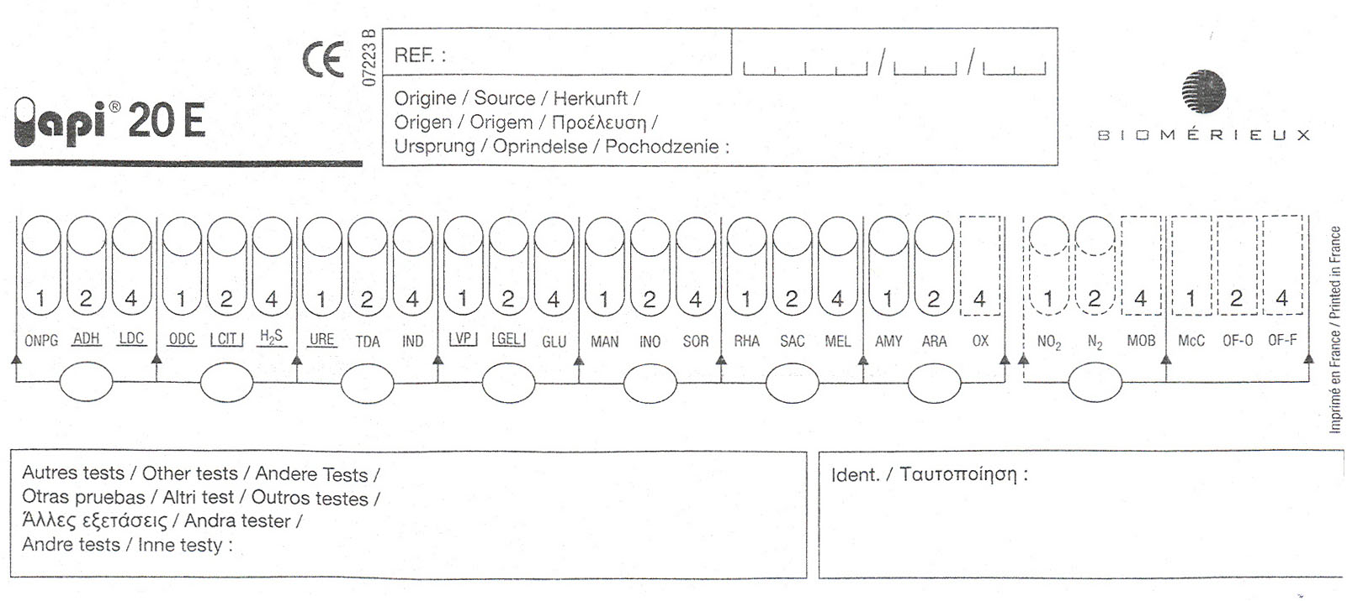
Figure 4.4: api®20E Test Report Form

5. Identify the organism using the analytical profile on the lab bench or sheets available from your instructor. In “Salmonella spp.,” the “spp.” means that the organism is in the Salmonella genus, but could be any one of a number of species. Try to identify your organism to the level of species. Make certain to record your unknown number.

Interpreting Antibiotic Sensitivity “Zones of Inhibition"
1. Retrieve the antibiotic sensitivity plates from the bin.
2. Identify antibiotics that lack a zone of inhibition, and record the result as “No zone of inhibition” (Table 4-10).
3. Identify antibiotic discs encircled by a zone of inhibition (Figures 4-11 & 4-12).
a. Place the edge of the metric ruler on the back of the bottom of the TSY plate so that the zero hash mark is lined up with one edge of the zone.
b. Measure the diameter of the zone in millimeters through the middle of the disc, and record the result
in the second table that follows.
c. Use the table immediately below to interpret your results. S = sensitive, R = resistant, I = intermediate sensitivity

Table 4-10: Antibiotic sensitivity measurements and results
 |  | Sensitive |  | Resistant
penicillin |  | > 29 mm |  | < 28 mm
erythromycin |  | > 18 |  | < 13
ciprofloxacin |  | > 18 |  | < 12
tetracycline |  | > 19 |  | < 14
oxacillin |  | > 17 |  | < 12
sulfadiazine |  | > 16 |  | < 10
 | Size of zone | S, R, I | Mechanism of action of antibiotic |  | Result expected? Y or N
penicillin

oxacillin

sulfadiazine

tetracycline

erythromycin

ciprofloxacin

Zone of Inhibition
No Zone of Inhibition
Figure 4-11: Antibiotic Discs on an Inoculated TSY Plate
Te
P
E

Antibiotic Discs

P
Te
E
Record 10 mm
Millimeters
Rulerrr

Figure 4-12: Measuring the Zone of Inhibition

LAB REPORT:
Use the standard format to produce a lab report for this project. Complete one lab report per lab group (i.e. two people). Topics to consider in your introduction include:
- Consolidation of two techniques (staining and media) to determine genus and species
- Expansion of testing capability using API 20E & antibiotic sensitivity
Make certain to include clearly labeled results for the identification of the unknowns, to the genus and species level, for both lab partners.

Include a robust discussion of your results and potential sources of error.

