Leica LAS EZ Microscope Camera Software Instructions and Tips

Throughout the semester, we will be taking photomicrographs using the Leica ICC50HD Microscope Camera. Here are some tips on how to use the software to obtain and label photos.

WHERE TO START:
Obtain your microscope from the cabinet. Plug it into an outlet, and turn on the power using the green toggle at the base.
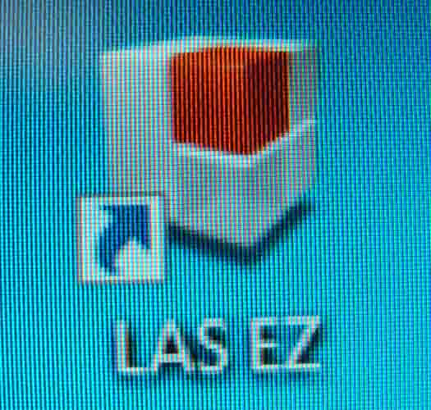
3. Once your scope camera and laptop are connected, click on the LAS EZ software icon on your desktop (Pictured to the left.).

The photo to the right is what the software application looks like when it is open on your laptop.
2. If your scope has a camera, you will see a port on the back of the scope where you can connect your scope to your computer. This cord for this is in the same drawer as your laptop. When you connect your camera to your computer, the camera will beep.

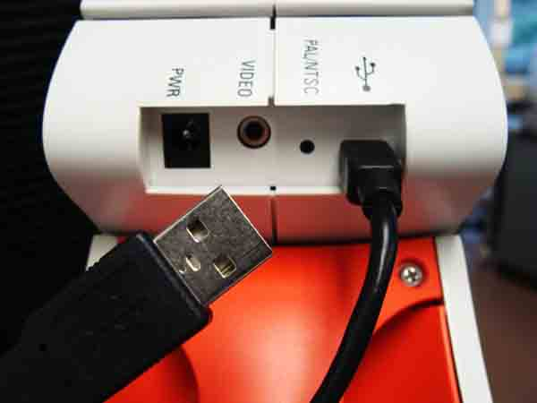
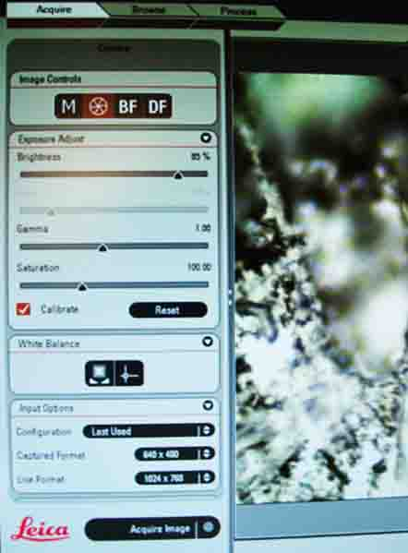
HOW TO TAKE A PHOTO:
Once you open the software, you will find three tabs in the upper right area of your screen: Acquire, Browse & Process. You must be in Acquire to take a photo.

Calibrating for Measurement: There are several panels available under Acquire tab. Inside the Exposure Adjust panel, click Calibrate, so that there is a check on the box. A pop-up will appear for you to select the objective magnification you are using. Making this selection will allow you to take measurements of specimens.

Photo file Size: In the Input Options panel, you can select the Captured Format (file size of your photos). Typically you will want to select the smallest size 640 x 480, unless you plan to crop your image. If you will be doing any cropping, you will probably want to use the largest Capture Format, or else your cropped image will look pixelated. Just make sure you don’t have huge photo files, as including several photos with big file sizes in your lab report will make the file size of your report HUGE.

Acquiring An Image: When you have your specimen in focus, check to see if changing the light level improves your image. Once you are satisfied with how your specimen looks on the screen click the Acquire Image button, on the bottom left of the screen. Your display will now change from the Acquire tab to the Browse tab, where you can see the photos you have taken at the bottom of the page. Your images will automatically be saved to your O: drive, and named “image”, followed by a number.

Renaming Your Image: It is a good idea to change the name of your images to make it more descriptive. If you right click on your image, at the bottom of the screen, a menu will appear, and one of the choices is Rename Current Image. Click this and you will be prompted to enter a new file name.

HOW TO ENHANCE A PHOTO:
Under the Process tab, there are numerous options that allow you add labels, arrows, measurements and in other ways enhance your photos. There are three sub-tabs under the Process tab: Annotate, Calib & Enhance.

General Label for Your Photo: You can put a general title or the magnification the picture was obtained at under the Annotate tab Information panel. Click on the box that says Description, and in the box below, enter your text.

Measuring Your Specimen: If you calibrated your scope initially (see instructions above) you can measure your specimen. Under the Annotate tab, in the Line panel, click the Show box, so that it has a check mark in it. From the dropdown that says Edit for the first choice, select Distance Line. The cursor will become a + shape. Place the + on one edge of the specimen and click. Then drag to cursor across your specimen, and click again. A line appears over your specimen as you do this, and then a text box appears with the length of your distance line.

Moving the Text Boxes Around on Your Image: If you would like to move the measurement text box so that it is not on top of your specimen, select Edit from the dropdown menu in the Line panel. Once you do this, you can move any text boxes around on your image.

Changing the Font or Text Size: You can adjust the size and appearance of any text you’ve added to your picture under the Annotate tab and the Font panel. Click the Select button and a window will pop up allowing your to adjust the text. Remember, in lab reports, the photomicrograph you include will probably we relatively small, and if the font size of the labels is not very large, it will not be legible. So use a larger font size.

Saving or Clearing Your Annotations: The last panel under the Annotate tab is titled Actions none of the anotations that you make will be applied to the photo until your click Merge. Once you click Merge, the changes will become a permanent part of your image. Before merging, you can clear annotations by selecting the Clear button, in this same panel.

How to Crop and Image: Under the Enhance tab there is a panel that says Crop. Selecting Crop will allow you to draw box to encompass the area you are selecting. Click the Finish button to crop the photo. If you are happy with the crop, click on the Apply button in the Confirm panel. To undo the crop, click on the Discard button in the control panel.

